TRAFFIC FLOW MANAGEMENT SYSTEM

LOGICAL MODEL:

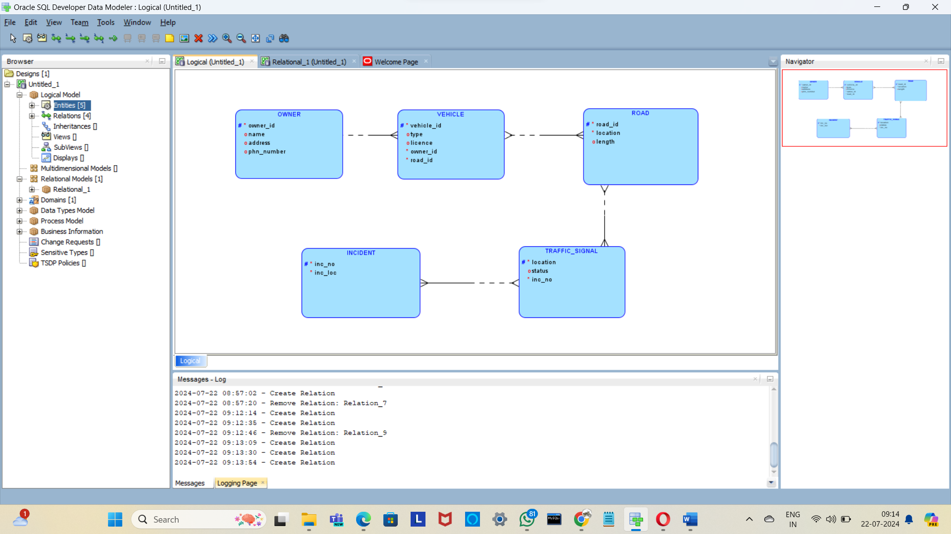

RELATIONAL MODEL:

